# Documentation

**2.1 Command Line Tips & Tricks**

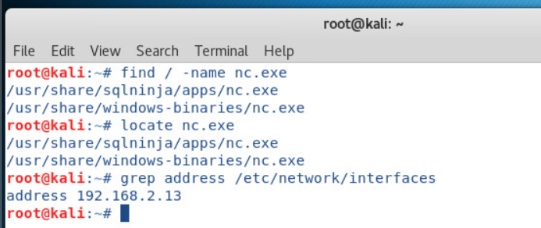

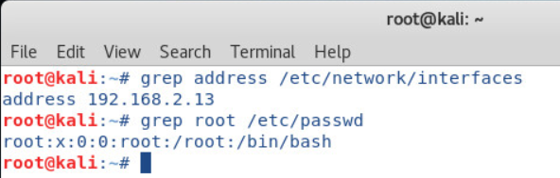

**2.2 Linux Networking for Hackers (The instruction wasn’t very clear. So, I went ahead and followed the lab guide and executed the command in Linux kali.)**

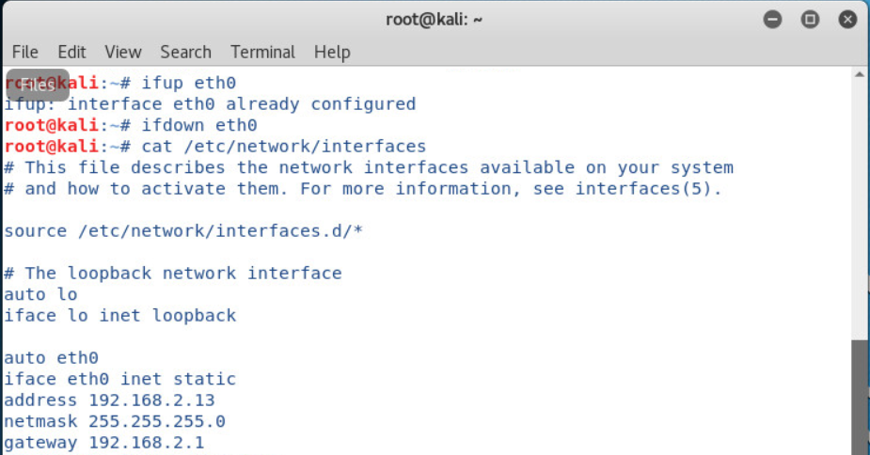

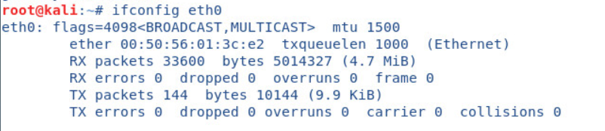

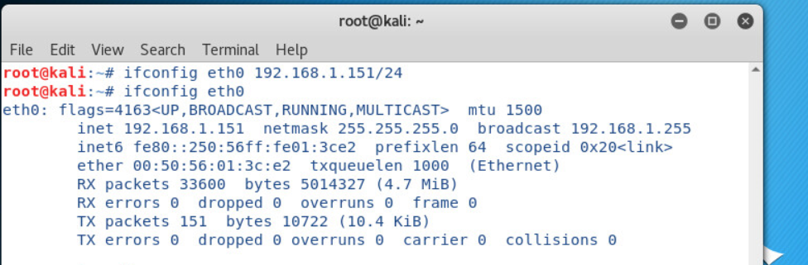







**2.3 Files**

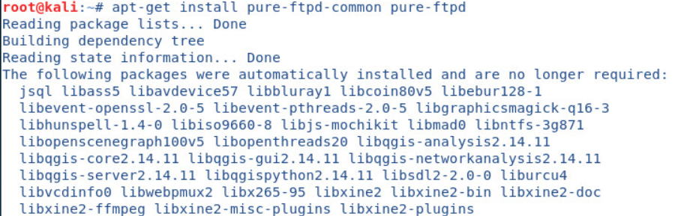

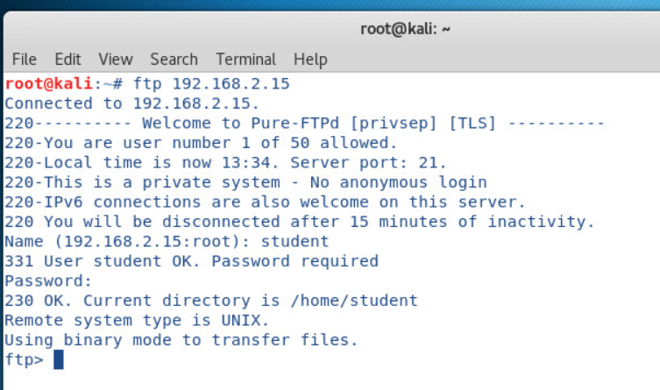

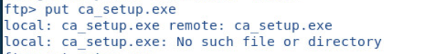

There’s no file called ca_setup.exe. The rest of the lab depends on this file. So, I skipped with Professor Schott’s permission.

# Vulnerabilities

No vulnerabilities discovered in this lab.